**IDEATION PHASE**

**Brainstrom & Prioritize**

|  |  |
| --- | --- |
| **NM ID** | **8073B6FD2C609D2A026419D64F1FD32** |
| **PROJECT TITTLE** | **BUILD IN EVENT MANAGEMENT USING SALESFORCE** |

**1. Start with the Right Salesforce Event Management App**

Before you can jump into event-planning, you’ll need to find an event management solution to help you keep track of all the moving pieces of your event.

**Why This Step Matters**

In order to streamline your event management experience (and limit potential pitfalls), you should find an event management app that works with your Salesforce CRM platform.

**The benefit of working with a [Salesforce app](https://events.fonteva.com/best-salesforce-apps/), as opposed to a separate platform, is that all your data will be available in one place.**

If you’ve ever planned an event before, you know how important it is to have all relevant data on hand to plan events that are customized for your audience. Planning generic events that aren’t responsive to your attendees’ preferences, interests, or lifestyles won’t be very profitable and might deter guests from attending future events.

**How to Plan Your Salesforce Event with This in Mind**

The best starting point for your software search is understanding the difference between native Salesforce applications and non-native apps.

**Put simply, a native app is one that was built to work within your Salesforce CRM. A non-native app, on the other hand, is built on a third-party platform and must be integrated.**

You can learn more about the differences by examining our [in-depth look at the topic](https://events.fonteva.com/salesforce-native-app/), but for now, consider these benefits of using a native app:

* **Guaranteed compatibility.**You won’t have to worry about external platforms, additional setup, or third-party data storage. Since all your information resides in one system, everything you need automatically works together perfectly—absolutely no integration required!
* **Continual data updates.**You need your guest data to maintain accuracy in real-time, and a native app is the only way to ensure that! Since all data is housed together, all of your information is continually updated with no added effort on your end.
* **Reduced manual data entry.**When you work within two platforms, there’s always a risk that incomplete data will find its way to your database, meaning you’ll consistently have to check and re-enter information. Since a native app updates on its own, there’s less risk for error *and* less time spent on data entry.

Not sure what to look for in a Salesforce app? [Our list of top features](https://events.fonteva.com/top-salesforce-features/) can help you find the perfect tool for your organization’s needs.

**Check this off your Salesforce event to-do list when you’ve found the right native app to launch your event management project!**

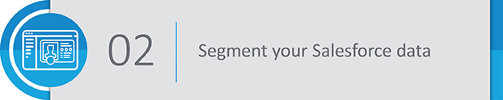

**2. Segment Your Salesforce Data**

Like most organizations, your Salesforce database is likely bursting with useful information. Now it’s time to put it to use for your upcoming event.

**Why This Step Matters**

As mentioned, planning generic events won’t leave any of your guests feeling good about signing up for any future conferences, meetings, or fundraisers your organization might host.

**However, if you use your Salesforce data to tailor your event-planning tactics, your guests are sure to take notice!**

You can segment your data using custom fields, and use the intel you collect to design pitch-perfect events that are designed with your attendees in mind.

**How to Plan Your Salesforce Event with This in Mind**

You can segment your data to find pretty much any information you need, but when it comes to events, there are a few especially important ways you can use data segmentation:

* **Set ticket pricing levels.**Segment your list by past giving history or income level to determine an appropriate ticket pricing strategy. You can use this information to pinpoint the perfect general admission price, or take a more customized strategy ([more on that below](https://events.fonteva.com/salesforce-event-planning/#pricing)!).
* **Develop a guest list.**Instead of casting a wide net across your entire database, start putting together a guest list with the most likely attendees. You can tailor your invitation approach by first setting an exclusive RSVP list and go from there to create a general admission list.
* **Send targeted communications.**You can filter your database by communication preference to make sure you’re reaching out to constituents in the most advantageous way. You can also use relevant data to make sure your emails, calls, and direct mailings are as personalized as possible.

**Check this off your Salesforce event to-do list when you’ve segmented your database and come away with relevant insights that can help your event be more strategic, profitable, and guest-specific.**



**3. Set Custom Pricing Levels for Your Salesforce Event**

All events are different, and they require different ticket pricing and registration options. For most events, you can’t just select one general ticket price and move on; you need to customize your pricing levels!

**Why This Step Matters**

In order to continue hosting events (and keep your organization afloat), you need to plan events that are budget-conscious and lucrative. Ticket sales are a major part of that equation.

On the other hand, it’s also imperative that your organization considers your constituents’ budgets and sets registration fees that your guests can actually afford.

How do you solve both those problems at once? **Use your Salesforce event management app to devise a pricing plan that’s customized to your guests and can help you bring in the ticket sales you need.**

*[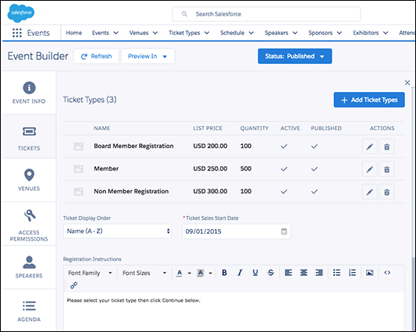](https://www.fonteva.com/events/)*

*For this Salesforce event, there are three simple ticket types: board member, member, and non-member, each with their own price and quantity. With Fonteva Events, you can even unpublish certain listings to keep registration options hidden.*

**How to Plan Your Salesforce Event with This in Mind**

Like many other aspects of your event, the ticket levels you choose will be uniquely reflective of your organization and your guests.

However, here are a few general price points to consider featuring to give your guests flexibility with their ticket options:

* **General admission.**The baseline price you’ll offer to most of your registrants, general admission ticket pricing should be based off of your guest list’s historic median giving amount. Of course, you also have to consider your event budget, including costs for venue, speakers, and technology.
* **VIP pricing.**This price point should be reserved for special subsections of your guest list, including members, major donors, or early-bird registrants. With this ticket, you might also want to offer additional VIP perks, such as special table assignments or exclusive access.
* **Personalized pricing.**Using the data you store in Salesforce, you can determine the most appropriate, effective ticket prices for specific groups or even individuals. You can refer to giving histories, membership levels, or other custom fields to create 100% custom pricing.

**Check this off your Salesforce event to-do list when you’ve priced your tickets according to your Salesforce data, guest list, and event goals. You’re ready to start selling!**



**4. Build an Event Microsite**

To make sure you fill all the seats on event day, you’ll need to consider your promotional tactics early on. While a multi-channel marketing approach is always encouraged, you’ll also want to make your event details easy to find for potential guests.

**Why This Step Matters**

Especially important for large events, a dedicated event webpage—also known as a microsite—serves as the center of all things event-related.

Think about it: do you want your guests to spend valuable time scouring your organization’s website, social media pages, and email newsletter archives to find out the information they need about your event? Or worse—**do you want potential guests to miss out on signing up for your event because they don’t know where to do it?**

That’s where your event microsite comes in! With a well-designed site, your guests will have a one-stop shop for anything and everything related to your event.

**How to Plan Your Salesforce Event with This in Mind**

Ideally, your Salesforce event management software should generate a site for you, automatically pulling event details from your database to populate the site.

To get the most out of your microsite, make sure to include all of the following:

* **Registration information.**Using your event management app, build or customize registration forms to place on your microsite. Since your microsite is already linked with your CRM, all the data you collect on your forms will be automatically filed into your database.
* **Merchandise catalog.**You can set up an online store to sell fixed-price items on your microsite. Guests can add these to their ticket purchase or buy the products they like individually.
* **Event details.**Date, time, and location should all be prominently displayed on the front page of your microsite, but you can also include separate tabs with speaker information, specific session details, and logistical information (e.g., parking, check-in times, etc).

*[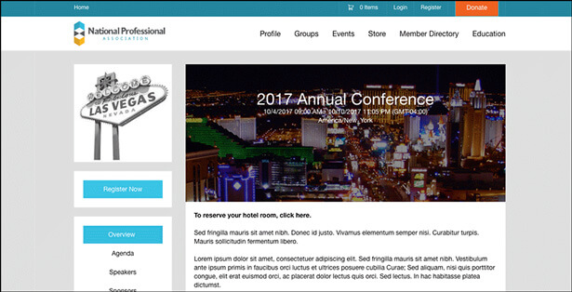](https://www.fonteva.com/events/)*

*This Salesforce event microsite features separate pages for agenda, speakers, eCommerce store, and more.*

**Check this off your Salesforce event to-do list when you’ve built a microsite to promote your upcoming event and share relevant details with guests.**

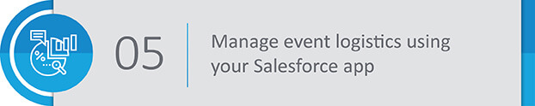

**5. Manage Event Logistics Using Your Salesforce App**

Every event planning team has a million responsibilities to stay on top of before (and during) the big day. Your Salesforce event management app can help you track those tasks!

**Why This Step Matters**

Now that you’ve gotten a lot of the “pre-prep” out of the way, it’s time to dive into the real event planning.

**Luckily, with an event management app that works within Salesforce, you won’t have to leave your CRM to manage all the details of your event, big or small.**

Having all your event data in one place lessens the possibility that you or your team will overlook an important detail. And, when event day rolls around, you won’t have to worry about juggling various platforms to stay on top of your plans—it will all be accessible in Salesforce!

**How to Plan Your Salesforce Event with This in Mind**

Within your Salesforce app, you can keep tabs on these important event considerations:

* **Venue.** Where will you hold your event? Is this location geographically accessible for your guests? Can the venue accommodate all of your guests? How many rooms will you need? Will you have access to a stage, projector, lighting and sound equipment, tables, or anything else you might need?
* **Sponsors.**Are there local businesses who’ve previously interacted with your organization? Do any of your constituents have ties to [generous corporations](https://www.360matchpro.com/top-matching-gift-companies/)? What sponsorship levels will you offer?
* **Speakers.**Who in your database might be a good fit to speak at your event? What speakers or topics might be most relevant to your guests’ interests? How does hiring a professional speaker fit into your event budget?

You’ll also be able to use your event management app to manage exhibitors, vendors, auction items, event sessions and/or tracks, table and seating charts, and many other elements that contribute to a successful event!

**Check this off your Salesforce event to-do list when you’ve used your Salesforce event management software to plan and track all the finer details of your event. It’s almost time for event day!**

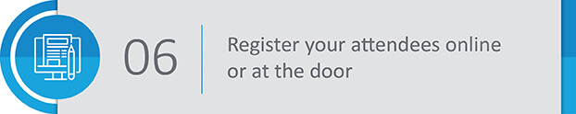

**6. Register Guests Online and at the Door**

Your event is well-planned and expertly promoted—all that’s missing are your guests!

**Why This Step Matters**

Having a strategy in place for registration can help your organization stay on track of your guest list *and*streamline the process for your attendees, too.

**Plus, accepting registrations in a variety of formats can help you maximize your event revenue and boost the turnout overall.**

**How to Plan Your Salesforce Event with This in Mind**

Depending on the scale of your event, it might make sense to offer online-only registration. However, offering registration onsite on event day can bring in additional last-minute ticket sales and help you fill in empty seats.

Regardless of which path you choose, follow these best practices for managing your guests’ registrations:

* **Make online registration mobile-friendly.**Smartphones and tablets are nothing if not universal. By mobile-optimizing your registration forms, you’ll make signing up or purchasing tickets for your event convenient for guests on the go.
* **Allow guests to build their own schedules.**If you’re hosting a conference or multi-day event with various tracks, sessions, and speakers, you should enable guests to design their own agendas based on their interests and availability.
* **Make multi-session signup intuitive.**For multi-session courses, guests should be able to quickly sign up for all events in a series at once. That way, their entire event schedule is mapped out, no extra effort needed.

**Check this off your Salesforce event to-do list when tickets are purchased, guest lists are set, and your registered attendees are ready for your event!**

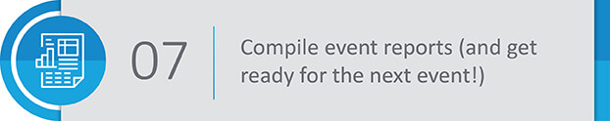

**7. Compile Event Reports (and Get Ready for the Next Event!)**

Event planning never stops, so you’ll need to assess the success of this event in order to achieve even greater heights at the next one.

**Why This Step Matters**

After event doors close and your team breathes a well-deserved sigh of relief, the work isn’t *quite*done yet.

**Before you can wrap up your event, you should analyze your success to see what elements of your event strategy were right on track and which ones lagged a little bit.**

By using reporting tools to objectively assess your success, you can improve your event-planning skills for the future and create more compelling events from now on.

**How to Plan Your Salesforce Event with This in Mind**

To get a good idea of how your event measured up, make use of these metrics:

* **Registration and attendance.**How many individuals registered for your event? How many of those attended? At what point did they register? What ticket level was the most widely purchase?
* **Cost-effectiveness.**How many tickets did you sell? How did your profit compare to your budgetary expenses? Did you have other revenue streams, such as merchandise or donations?
* **Attendee engagement.**How do the responses from your pre-event survey compare to your post-event survey? Did your marketing tactics generate ticket sales, new social media followers, or new customers?

No matter how you measure success, what’s important is that you set concrete event goals and follow through on tracking your progress against them.

If keeping tabs on your success seems daunting, don’t worry—the right event management app should come with easy-to-use reporting and analytics features designed to make managing goals easier.

*[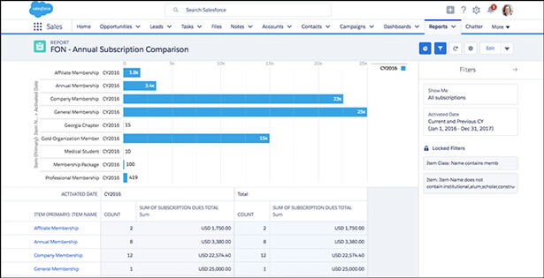](https://www.fonteva.com/events/)*

*This Salesforce event report measures membership attendance and subscriptions in an easy-to-view interface.*

**Check this off your Salesforce event to-do list when you know exactly how well your event performed and already know where to start for the next event!**

The perfectly planned event might be an abstract concept, but with a little help from the right event management software (not to mention your Salesforce data!), your organization will soon be one step closer to event success—and happy guests!

For more help planning your next event in Salesforce, check out these additional resources:

* [**Salesforce Event Management: The Essential Guide.**](https://events.fonteva.com/salesforce-event-management-guide/)We’ve put everything you need to know about using your Salesforce system to plan engaging, inspiring events. Trust us: this is the last resource you’ll need for *everything* event management!
* [**Best Eventbrite Alternatives.**](https://events.fonteva.com/eventbrite-alternatives/)Thinking of using the web-based event platform Eventbrite to plan your Salesforce event? Before you commit, check out these solutions like Eventbrite (but better) for your event management needs.